Professor: Eugenio Rodriguez

Student: Mohamed Fahim El-Hewie

mohamed.el-hewie@snhu.edu

7-1 Final Project Submission
3D Objects
- Create low-polygon 3D representations of real-world objects.
  - Box,
  - Cone
  - Cylinder
  - Plane
  - Prism
  - Pyramid
  - Sphere
  - Tapered cylinder
  - Torus
The following screenshot depicts the creation of most of the required objects:
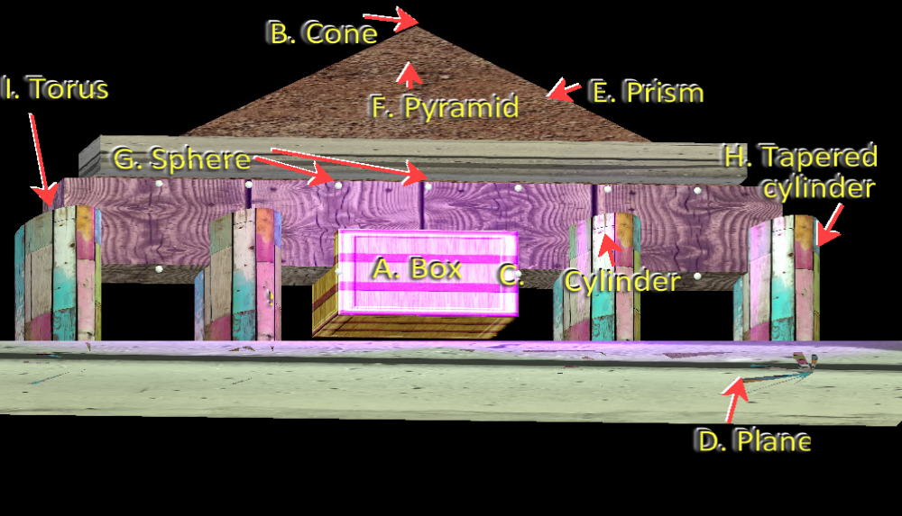

- Apply accurately projected textures to a 3D model.
The following 16 photos were downloaded from Google Image Search and comply with the requirements of seamless, square photos, royalty free, and larger than 2MB. Theses were used in wrapping the 3D shapes in the attached project.
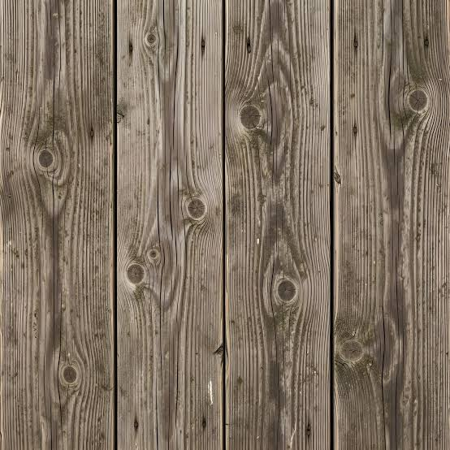 |  | 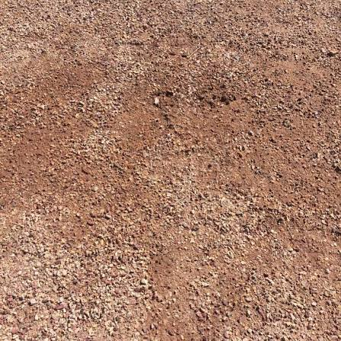 | 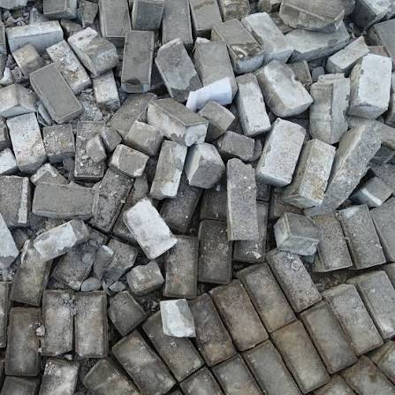
 |  | 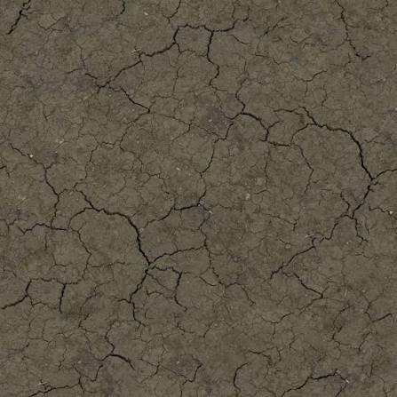 | 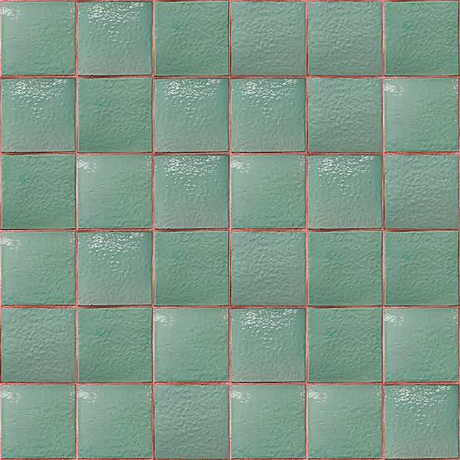
 |  |  | 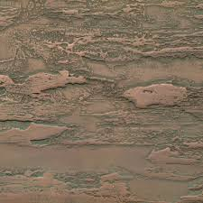
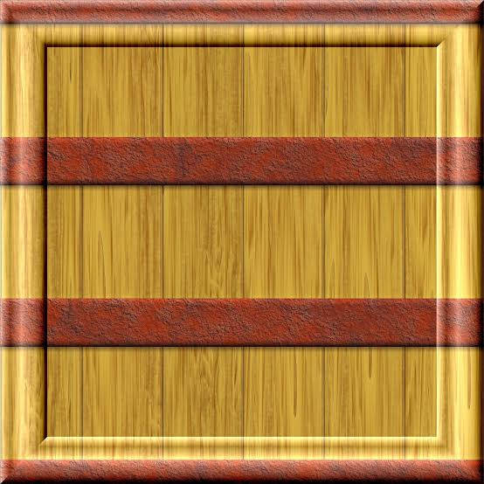 |  | 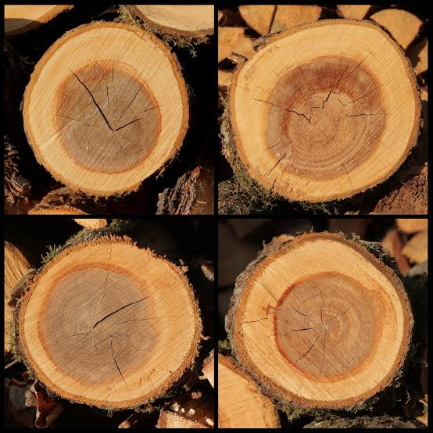 | 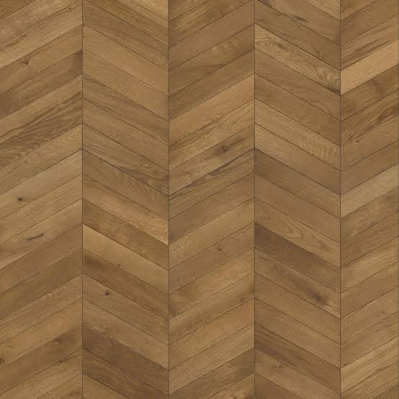
- Apply lighting to create a polished visualization of 3D models.
Six light sources were used to illuminate the scene as follows:
- Directional light illuminates the entire structure in the zy-plane, angled on the x-axis and has a yellowish white color.
- Spotlight illuminates the entrance tunnel with greenish-yellow color.
- Four point lights illuminate the façade of the structure with a magenta/purple color.
- Place objects appropriately, using the X, Y, and Z coordinates, relative to one another in the 3D world.
The complex structure was precisely arranged to simulate real-world architecture that serves both people’s needs and aesthetics standards.

Navigation
- Apply horizontal, vertical, and depth camera navigation around the 3D scene.
Both WASD and QE keys were implemented to control the forward, backward, left, and right motion, and the upward and downward movement, as required by the rubric.
- Apply nuanced camera controls to effectively view the 3D objects in the application. Changing
Both Mouse cursor and Mouse scroll are used to adjust the speed of the movement or the speed at which camera travels around the scene, as required by the rubric.
- Create perspective and orthographic displays of the 3D world.
Keyboard tap-keys are used to allow a user to change the viewport display of all objects in the scene between orthographic (2D) and perspective (3D) views.

Best Practices
- Apply coding best practices in formatting, commenting, and functional logic.
All three requirements are met ion formatting, commenting, and logical testing to achieve the end result of a standalone executable that meet the requirement of creating 3D objects, controlling the movement
Reflection
- Justify development choices for your 3D scene.
The 3D objects were chosen by the structural necessity of erecting a building on vertical supports, connecting these with horizontal beams in order to establish a compartmental structure to serve traffic flow in mountains. Each 3D shapes serves a purpose that ranged from mechanical support, walling a compartment, or diverting the flow of vehicles, and the likes.
The required functionality of the complex 3D shapes started by managing the three fundamental projections, starting from the horizontally leveled plane, dividing the plane into basic rectangles according to the intended needs. Vertical structures were designed on the leveled rectangles. Then farther structures continued to be added as the analysis and geometry were managed in dimensions and means of access.
- Explain how a user can navigate your 3D scene.
Controlling the virtual camera requires implementing both mouse and keyboard keys. The four-directional motions of a mouse on a flat pad control the pitch and yaw in half circle centered at the camera location. The mouse scroll controls the speed of movement of the scenes in that planar circle. The orthogonal translations are controlled by key QE and AD that moves the scene up/down, right/left. Zooming in and out is controlled by the WS keys.
- Explain the custom functions in your program that you are using to make your code more modular and organized.
The project of rendering 3D scenes is highly modularized due to the extreme complexity of managing geometry, trigonometry, and streaming of data between too many functions. Thus, the visual view is managed by a dedicated ViewManager module that controls the traffic flow between a SceneManager, ShaderManager, and supporting graphic libraries. Likewise, the SceneManager in dedicated to aggregating the definitions of methods that lead to rendering scene by orchestrating the calls to 3D MeshShapes, FramgentManager, and ShaderManager. The cycle of interdependence of modules encapsulates the complex details in files that are kept out of the direct attention of the developer.

